* 1. Inverse Function and its Properties

An **inverse function** means doing the same steps but in a reverse order. An **inverse function** is not a reciprocal function.

# To graph an inverse function:

* + 1. Make a table of values for the original function.
    2. Make a new table for the inverse function by interchanging the x and y values. (i.e. x become y and y becomes x)
    3. Graph the new table of values. *y*

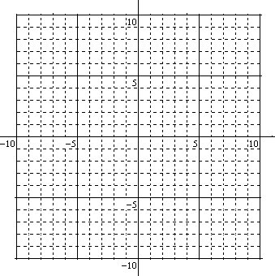

0

**Example 1:** Graph the inverse of *f*(*x*) = 4*x* – 5.

|  |  |
| --- | --- |
| ***x*** | ***y = f(x)*** |
|  |  |
|  |  |
|  |  |
|  |  |

|  |  |
| --- | --- |
| ***x*** | ***y = f--1(x)*** |
|  |  |
|  |  |
|  |  |
|  |  |

*x*

* Remember to label each graph.

# To determine the rule (equation) for an inverse function:

1. Rewrite the relation as an equation (replace the *f*(x) with *y*)
2. Isolate the *y* variable.
3. Interchange the *x* and *y* letters.
4. Isolate the **new** *y* variable using ALL of your algebraic skills.
5. Replace the **new** *y* with *f -1*(*x*).

**Example 2:** Determine the inverse function for the relation:

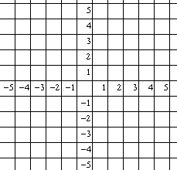

0

*f*(*x*) = 5*x* - 3. Sketch both on the grid.

